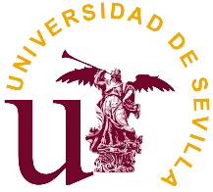 |  |  | 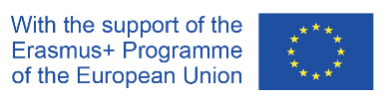

Erasmus+ Jean Monnet Network
Peace, War and the World in European Security Challenges

REGISTRATION FORM

International workshop
"The contribution of EU´s CSDP missions and operations
to the promotion of human rights in its wider neighborhood"

University of Seville
June 18, 2021 Online

1 | Title (Mr., Mrs., Ms., Prof., Dr. or other)
2 | Family name, First name
3 | Academic degree
4 | Institution
5 | Department/ Unit
6 | Position
7 | Contact number/ Mobile phone no
8 | E-mail
9 | Form of the intervention (speaker or participant)
10 | Theme of your speech (if a speaker)

Please send the completed forms to: cmarque@us.es

